EXPERIMENT NO. 1

**Aim**: To understand the benefits of Cloud Infrastructure and Setup AWS Cloud9 IDE, Launch AWS Cloud9 IDE and Perform Collaboration Demonstration.

**Steps with Screenshots**:

**Step 1**: Create AWS Console Account

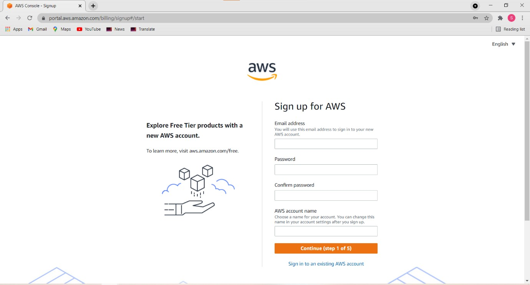

**Step 2**: Select Cloud 9 services

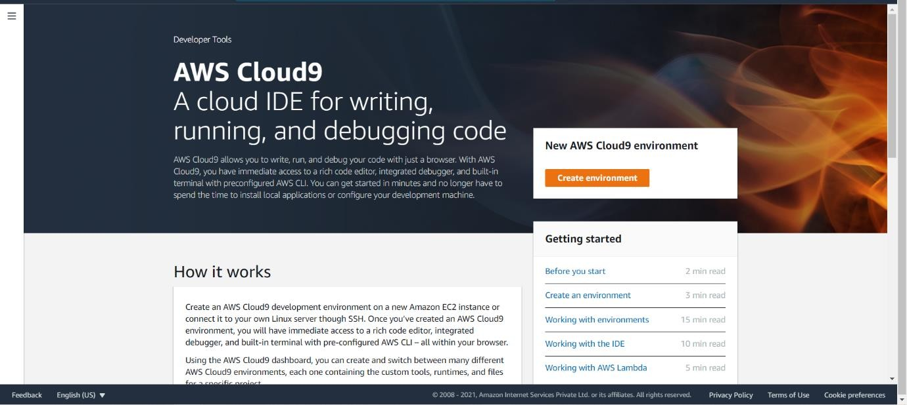

**Step 3**: Click on Create Environment Provide name for the Environment (DevOps) and click on next

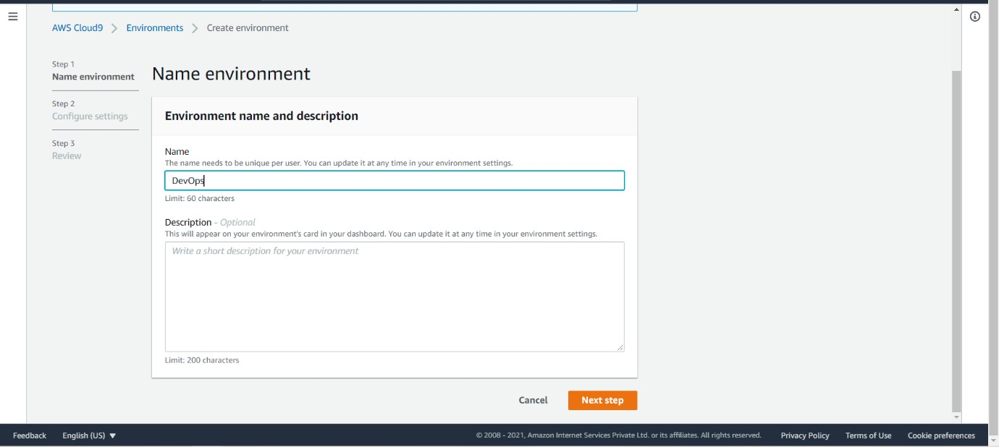

**Step 4**: Keep all the Default settings as shown below

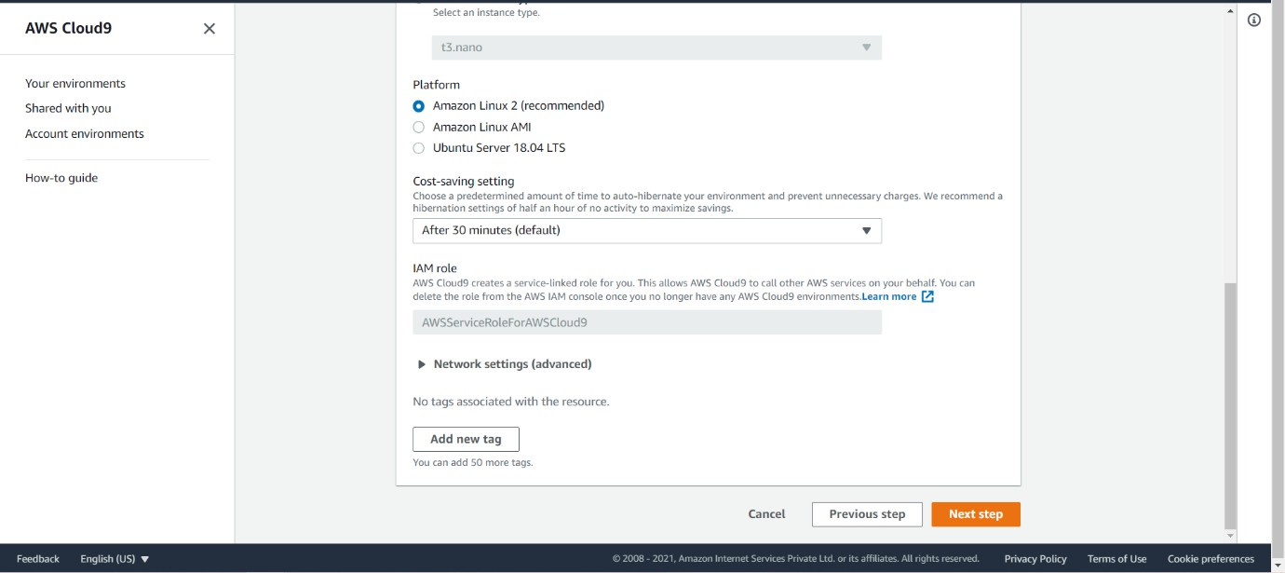

**Step 5**: Review the Environment name and Settings and click on Create Environment

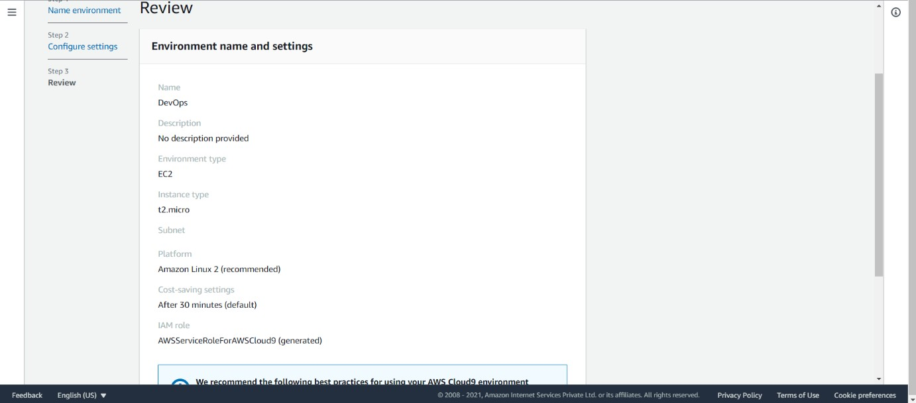

It will take few minutes to create AWS instance for your Cloud 9 Environment

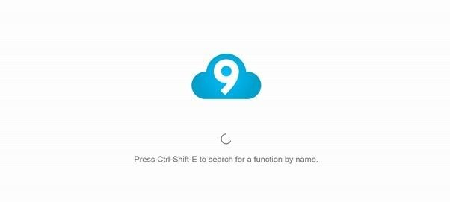

**Step 6**: Open IAM Identity and Access Management in order to add user in other tab

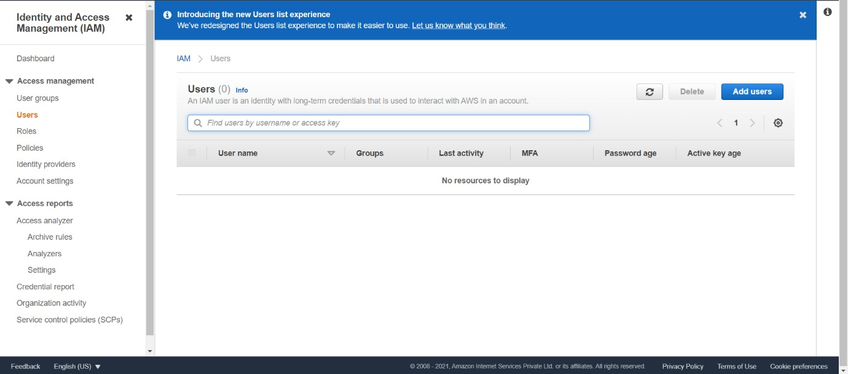

**Step 7**: Add user provide manual password and click next on permission tab

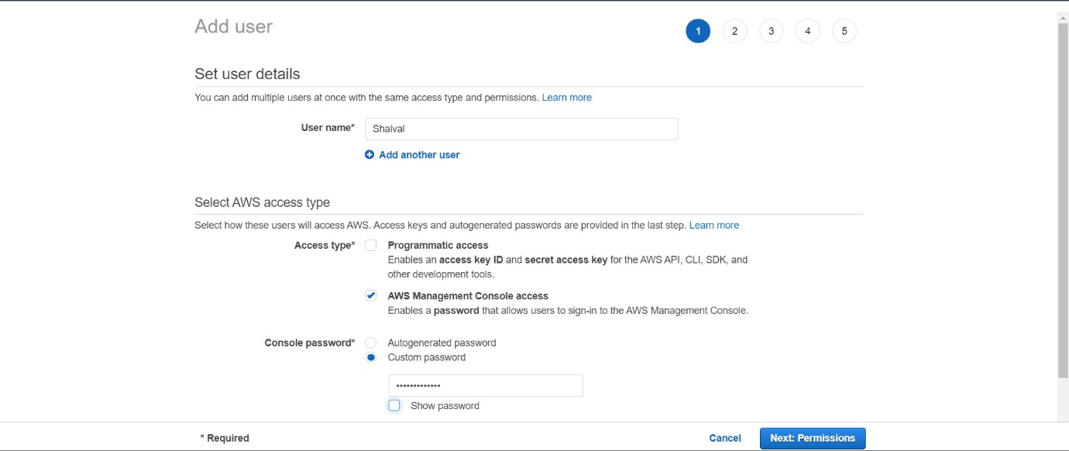

Durgesh

**Step 8** :Click on create group, provide group name and click on create group

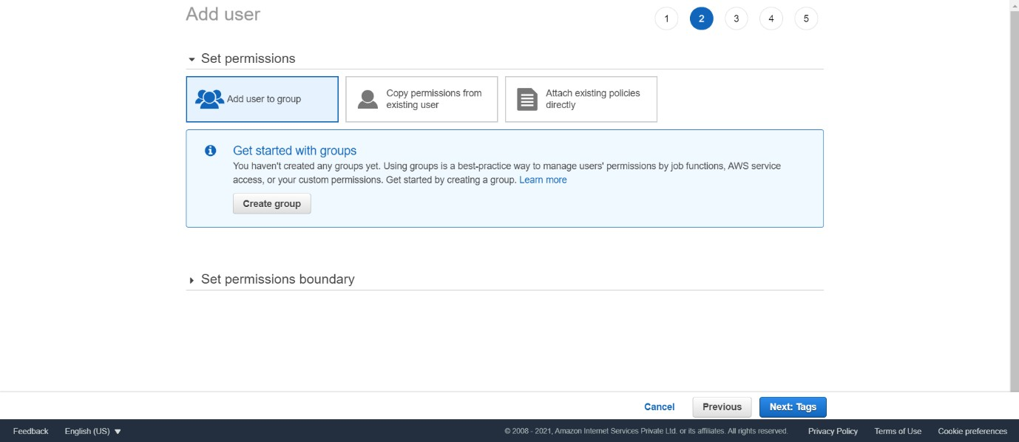

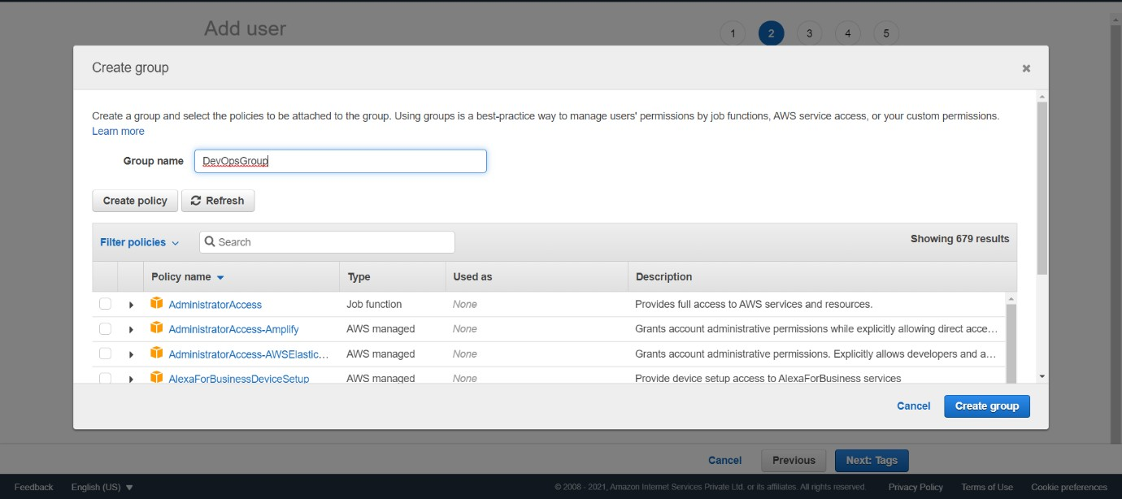

After that group is created click on next if u want to provide tag else click on Review for user settings and click on create user as shown in fig

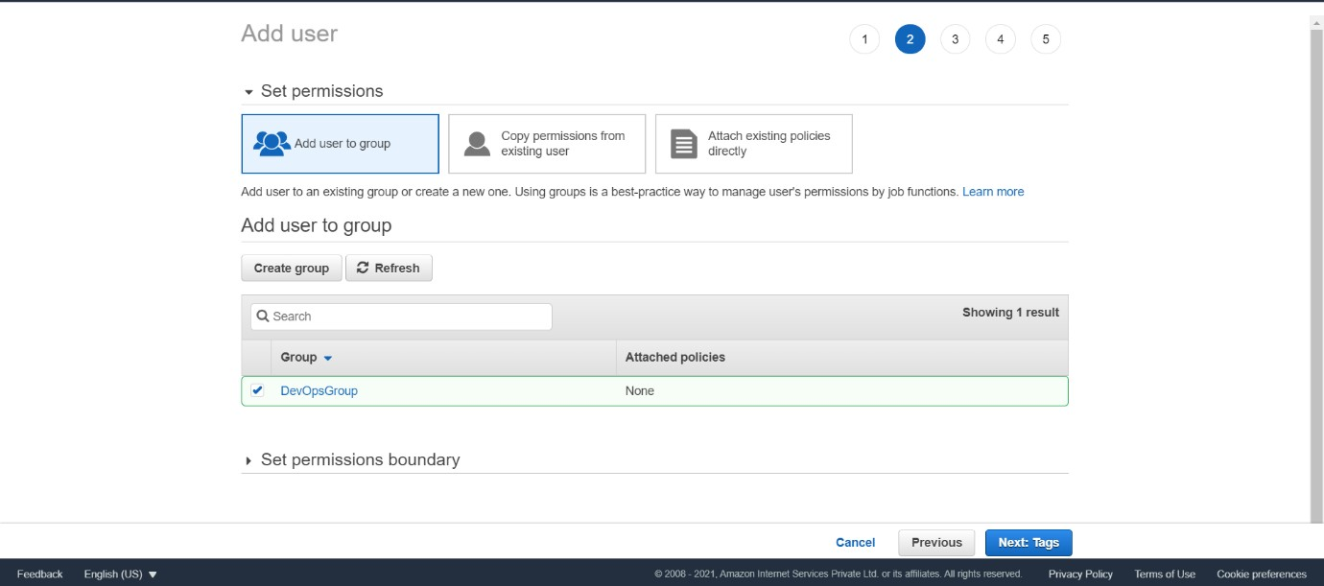

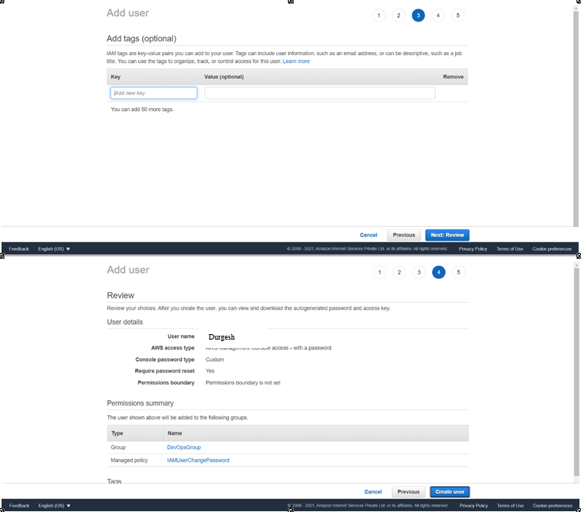

Durgesh

**Step 9** :Now close that window and Navigate to user Groups from left pane in IAM and click on your group name which you have created and navigate to permission tab as shown

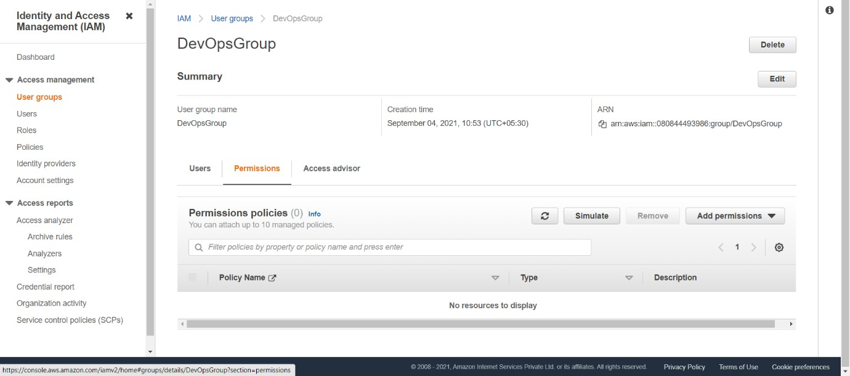

Now click on Add permission and select Attach Policy after that search for Cloud9 related policy and select Awscloud9EnviornmentMember policy and add it

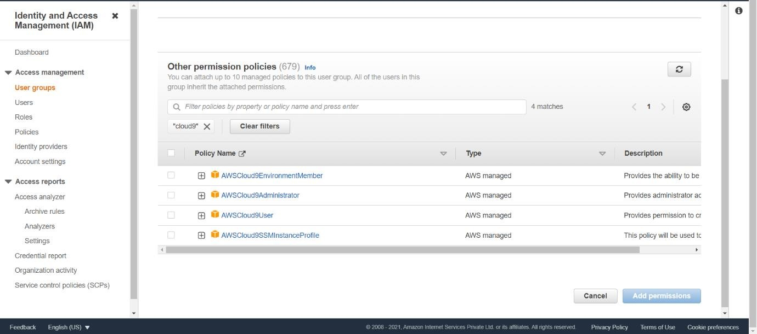

**Step 10**: Switch to environment created

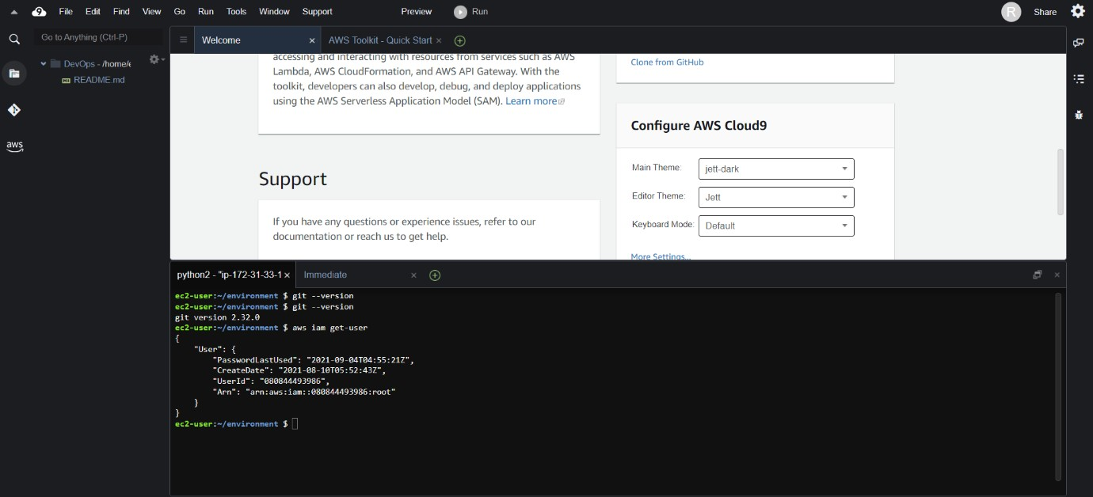

If you check at bottom side Cloud9 IDE also giving you and AWS CLI for command operations: as we here checked git version, I’m user details and so on…

Now we will setup collaborative environment Click on File you can create new file or choose from template, here I’m opting Html file to collaborate.

Edit Html file and save it compiled

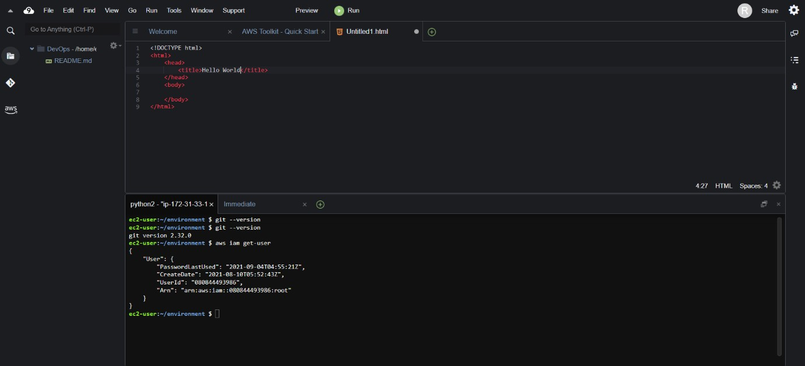

**Step 11** :Now in order to share this file to collaborate with other members of your team click on share option on Right Pane and username which you created in IAM before into invite members and enable permission as RW (Read and Write) and click on Done. Click OK for security warning.

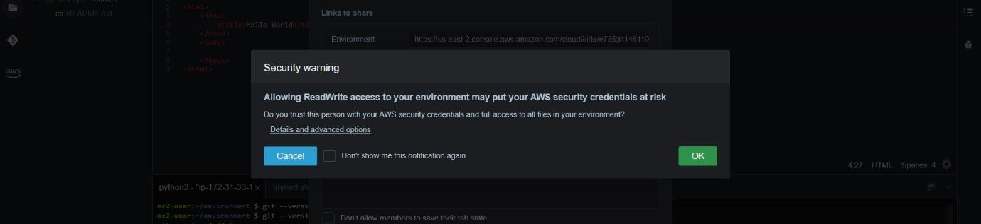

After Successful login with IAM user open Cloud9 service from dashboard services and click on shared with you environment to collaborate.

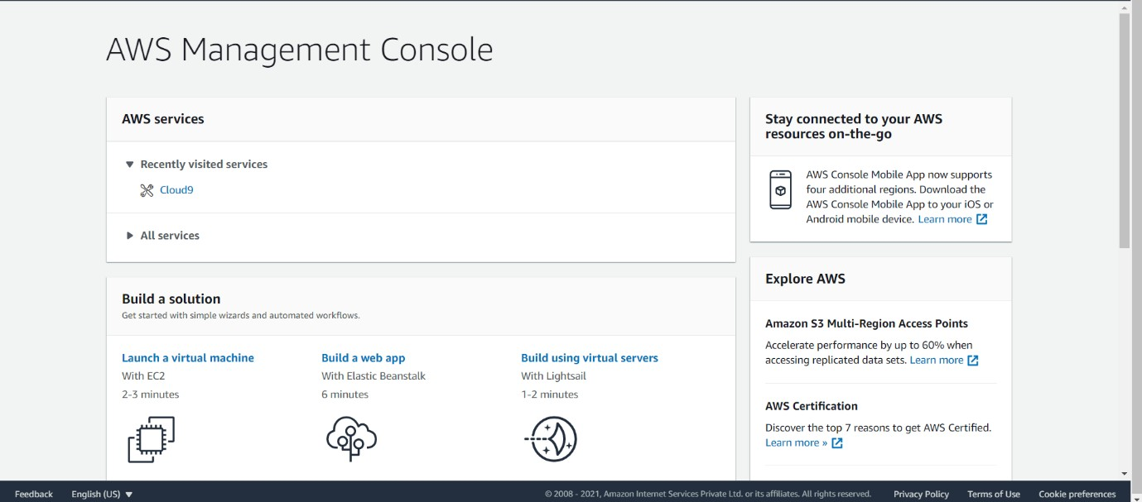

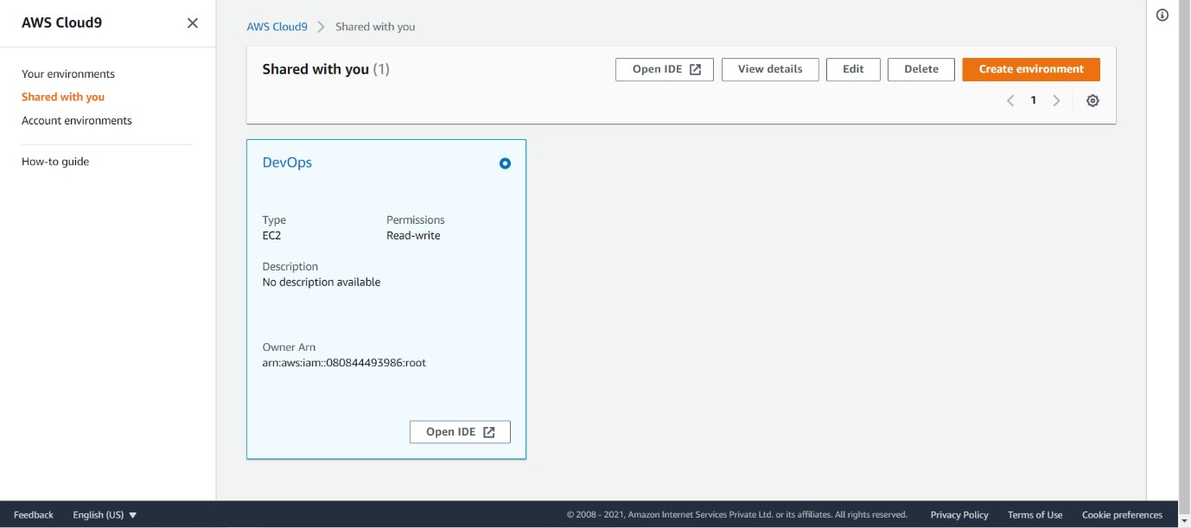

Click on Open IDE you will same interface as your other member have to collaborate in real time, also you all within team can do group chats as shown below

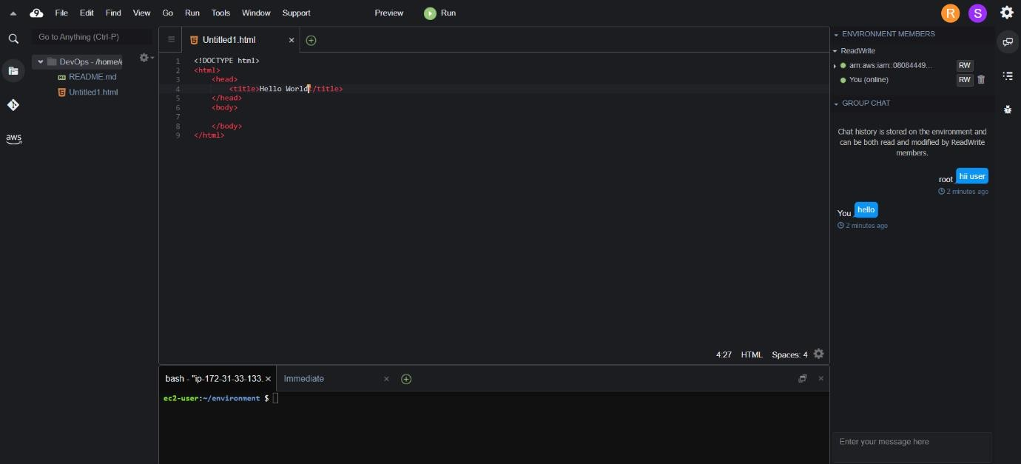

**Conclusion**: Hence, we learned to understand the benefits of Cloud Infrastructure and Setup AWS Cloud9 IDE, Launch AWS Cloud9 IDE and Perform Collaboration Demonstration.

**Lab Outcome**: ITL504.1 To understand the fundamentals of Cloud Computing and be fully proficient with Cloud based DevOps solution deployment options to meet your business requirements.